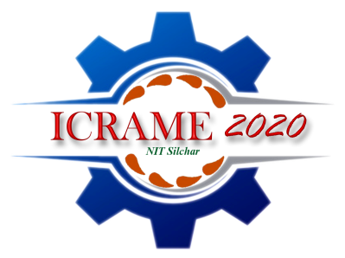
International Conference on Recent Advancement of Mechanical Engineering (ICRAME-2020)
07-09 February 2020
Registration form
*First Name: |  |  |  | *Family Name:
*Title: (Prof., Dr, Mr. Ms. etc.) |  |  |  |  |  | Male □ Female □
Category: Student Faculty/Academician Industry
* Participant’s Affiliation(Organization or University): |  |  |  |  |  |  |  |  |  | PHOTO  (*Please paste recent colour Photo here)
*Mailing Address:
*City: |  |  |  |  |  | *State/Province:
*Country: |  |  |  |  |  | *ZIP/Post Code:
*Tel.: |  | *E-mail: |  |  |  |  |  | Fax:
*Paper ID Code
*Paper Title
*Paper Author (s)
(List as the same order in the final paper)
*Paper Pages: |  |  |  |  |  |  | Additional Page:
*Transaction Details
*Amount | Rs.-  $- |  | *Name of the Bank  (Please Tick) |  | State Bank of  India |  |  |  |  |  | Axis Bank  Ltd.
*Transaction Reference No |  |  |  |  | *Date
*Signature of the Participant
* Compulsory items.

